Assignment – Database Services
1. MariaDB-Assignment-–-1
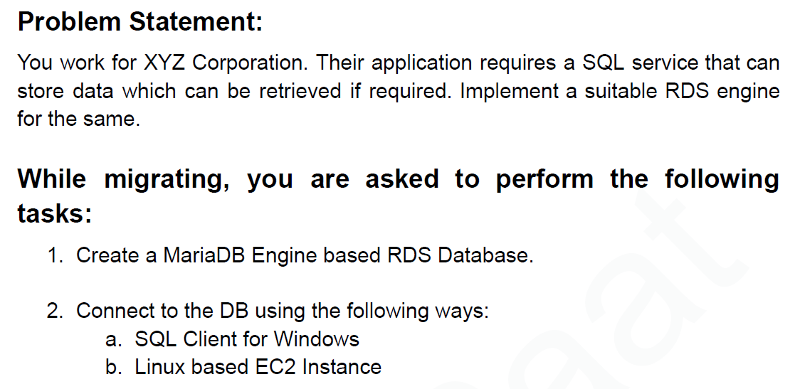

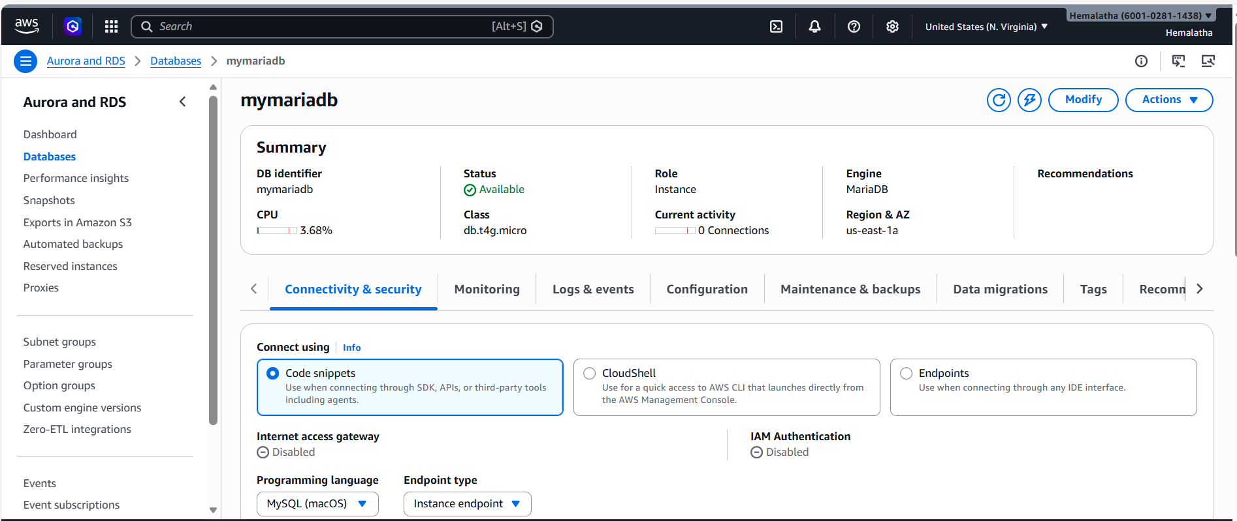

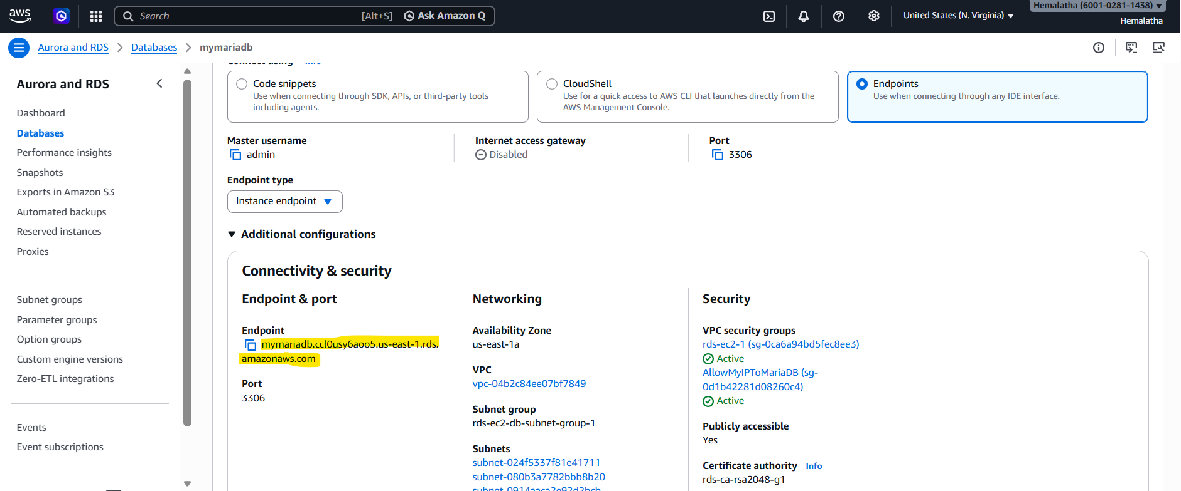

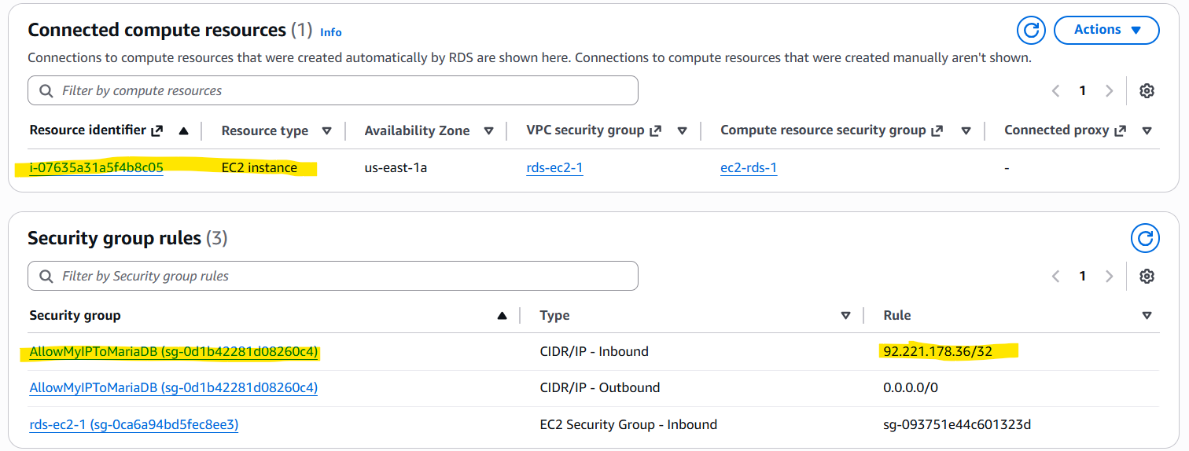

a. Connect to the DB using SQL Client for Windows:
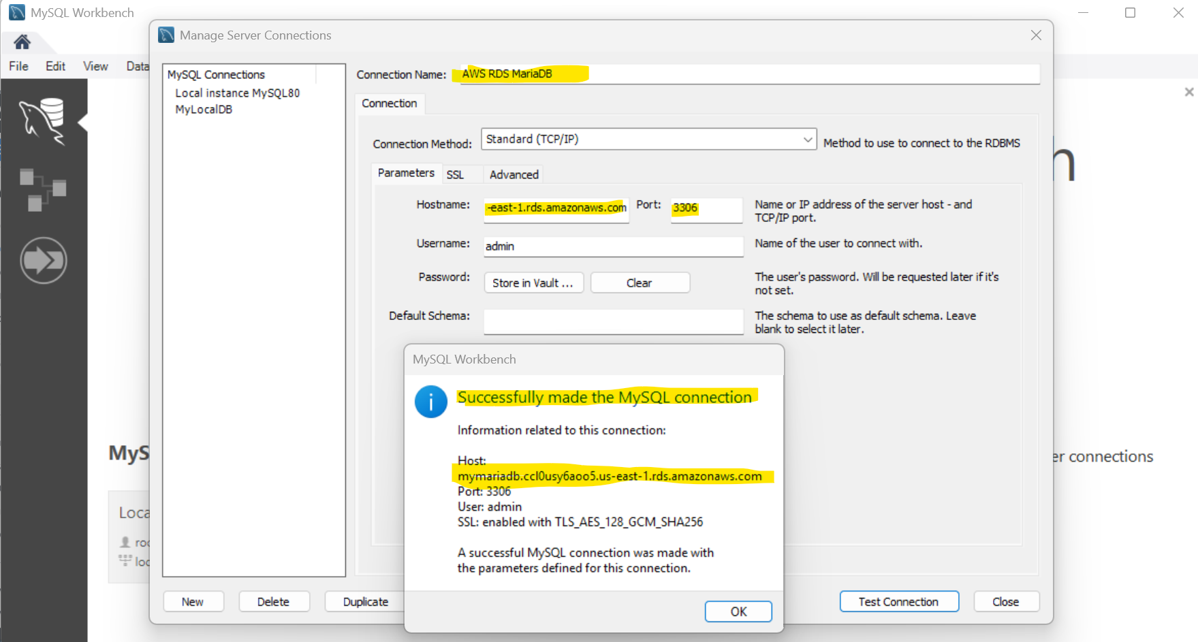

b. Connect to the DB using Linux based EC2 Instance:
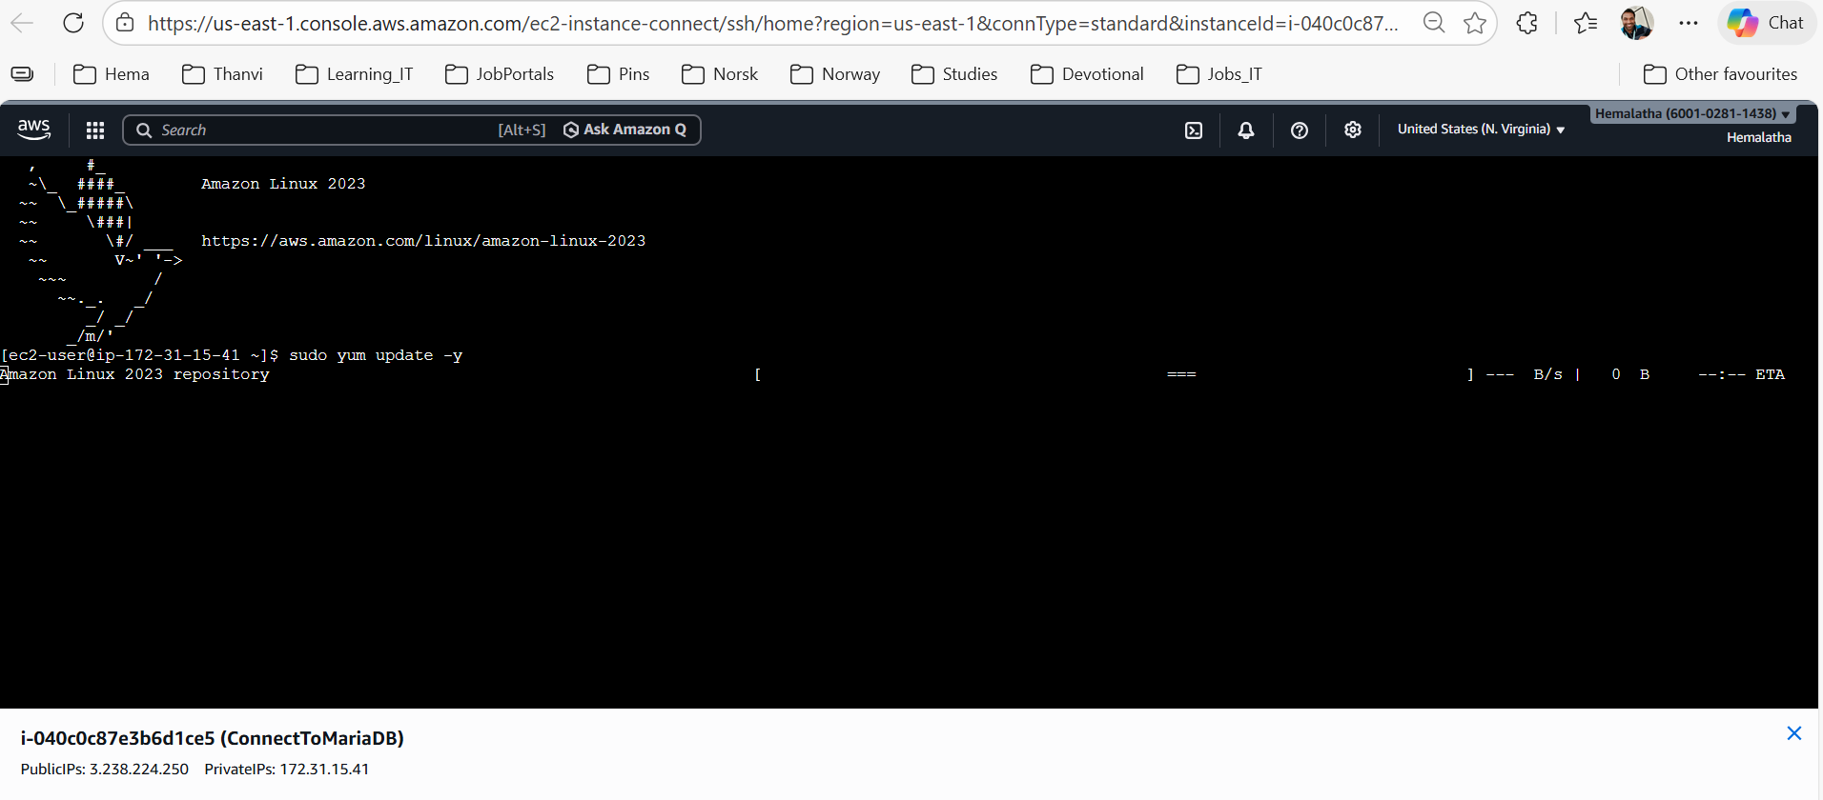

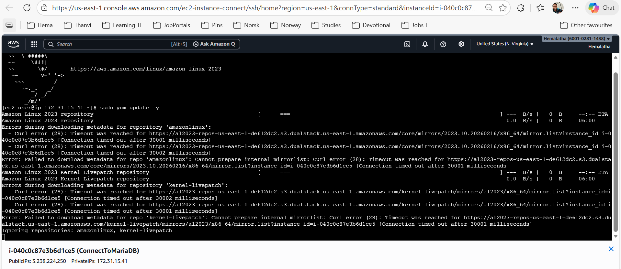
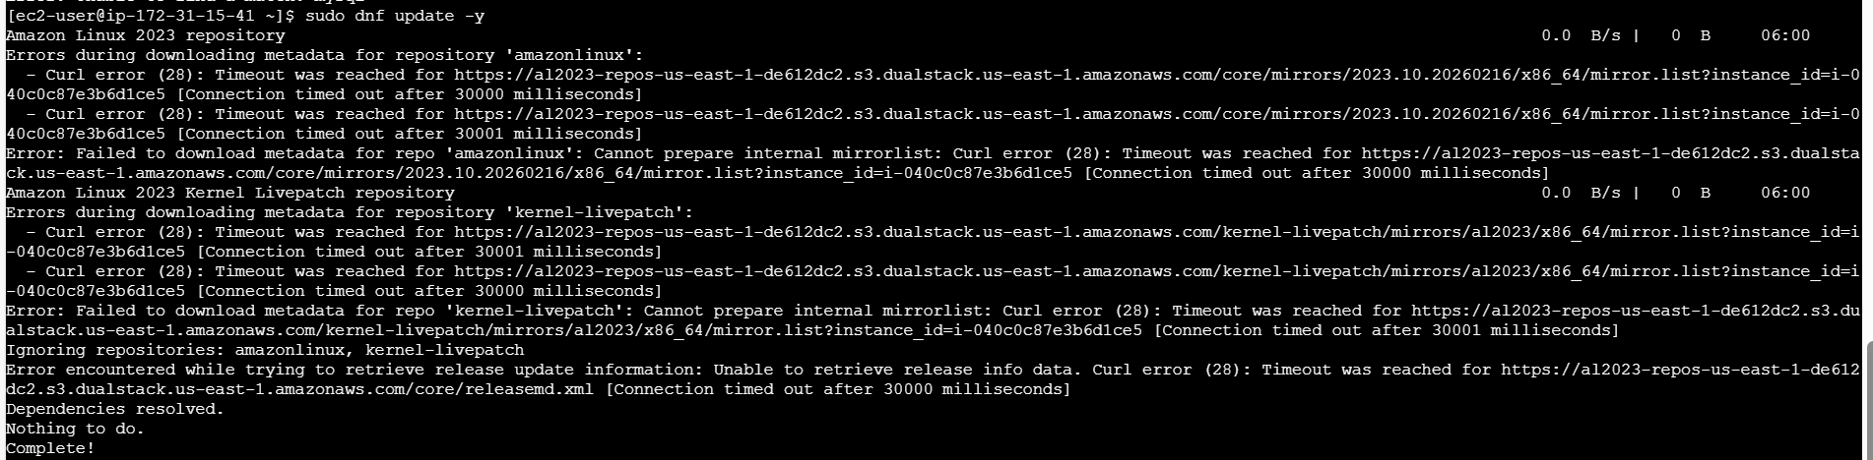
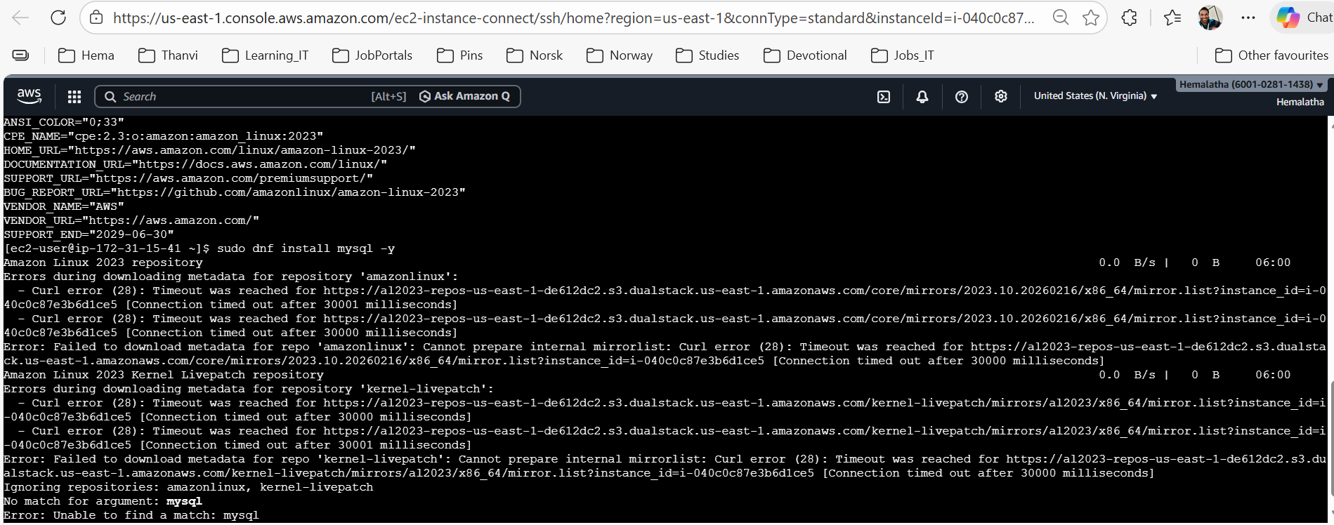

2. Aurora-Assignment-–-2
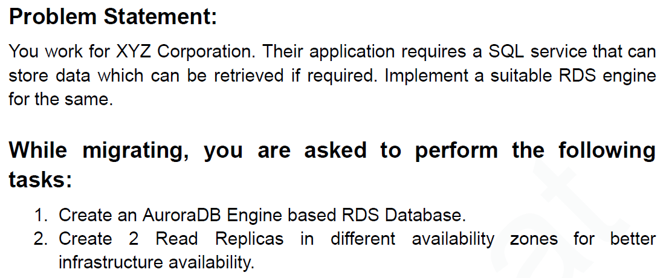

While creating AuroraDB based RDS Database, Aurora(MySQL Compatiable) and Aurora (PostgreSQL Compatible) are disabled for Free Tier AWS account.
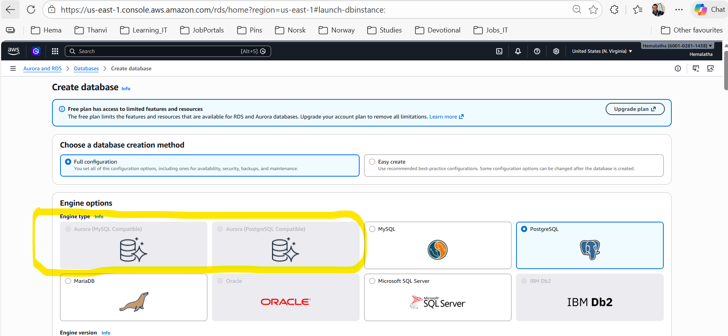

3. DynamoDB-Assignment-–-3
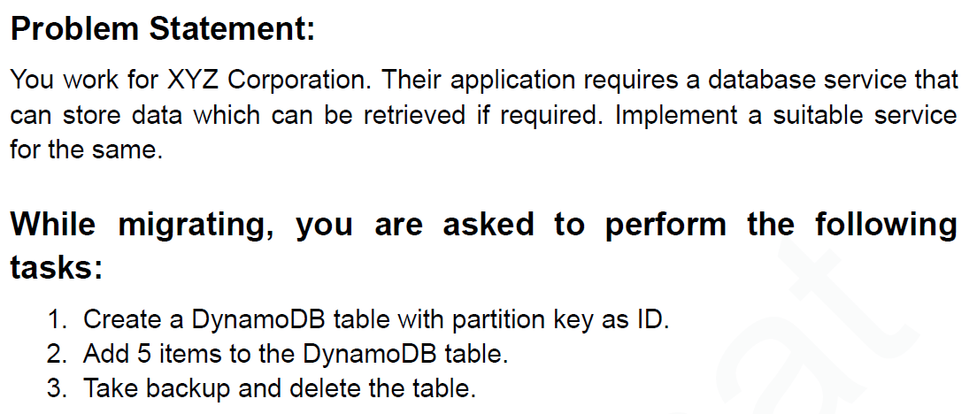
1. Created a DynamoDB table with partition key as ID:
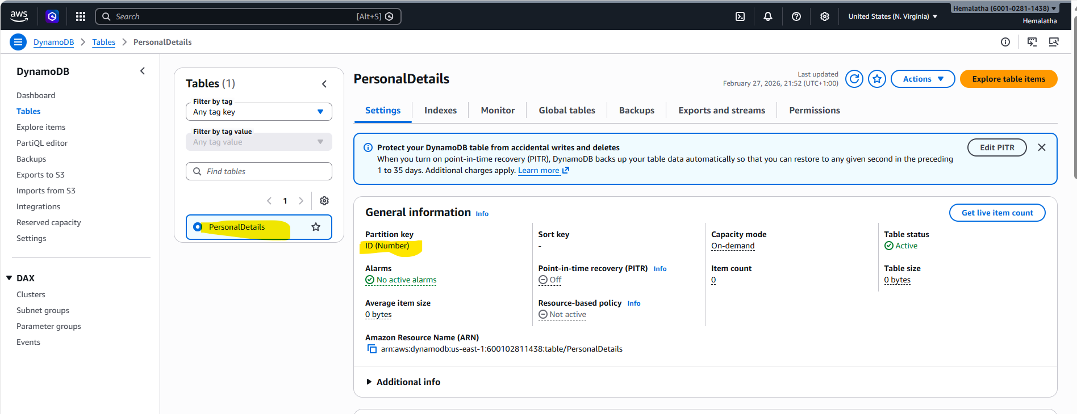
2. Added 5 items to the DynamoDB table:
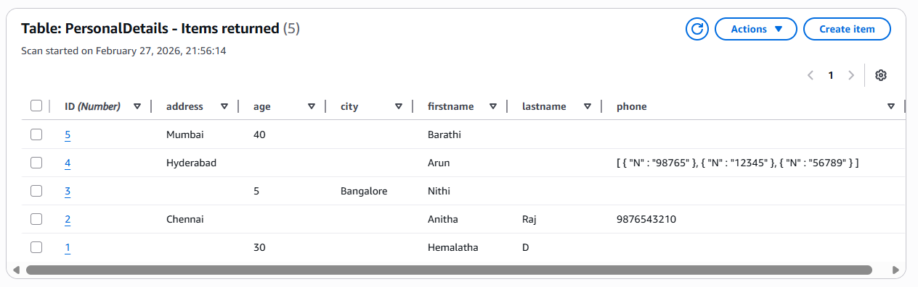

3. Taken backup and delete the table:
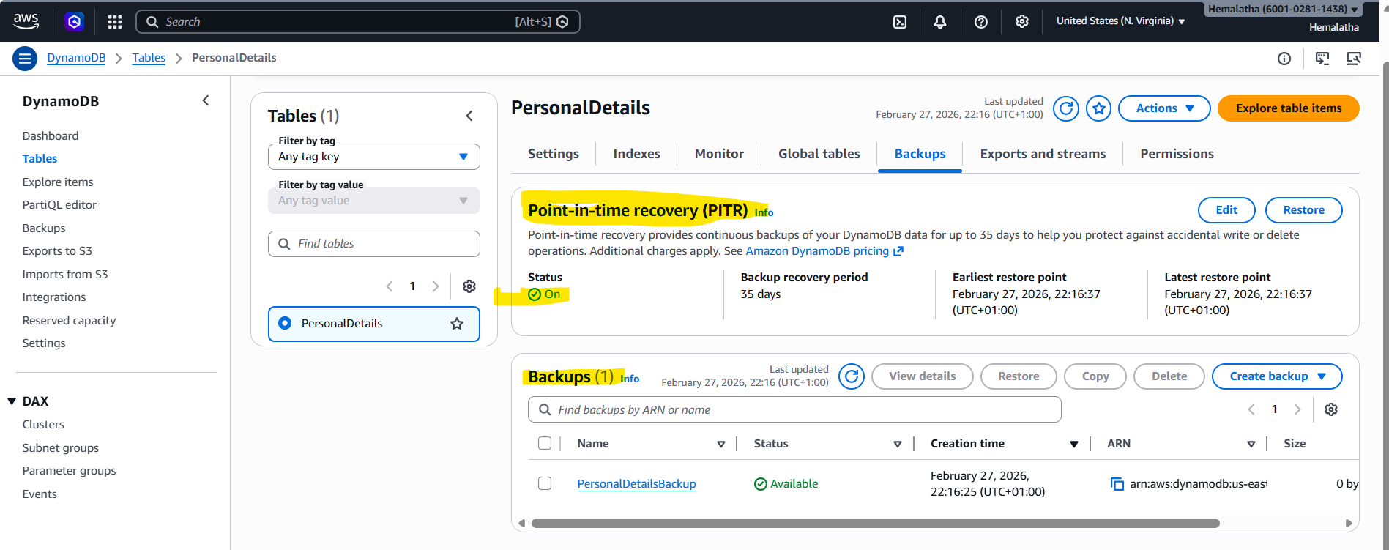
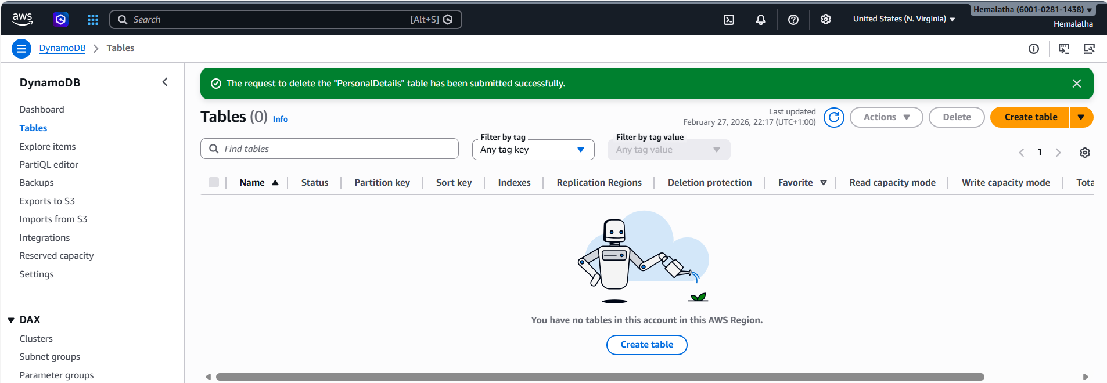

4. Redshift-Assignment-–-4
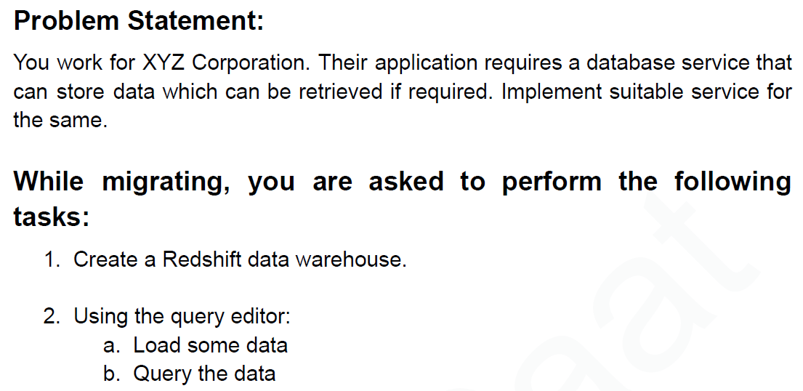

Unable to use Redshift on free tier account.
Tried the following fixes (None of them worked out):
- switching to us-east-1 (N. Virginia), eu-west-1 (Ireland) regions
- AWS Console → Account → AWS Regions → us-east-1 (N. Virginia), eu-west-1 (Ireland) regions → Enabled by default
- Creating Redshift Serverless – This also fails.

